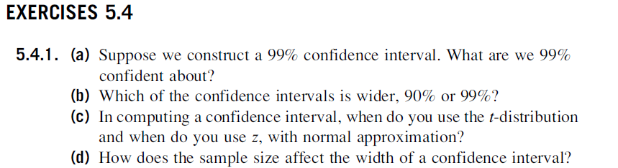



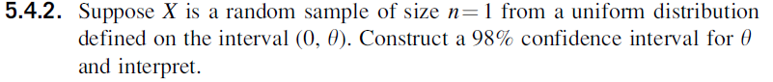



For  as a pivot

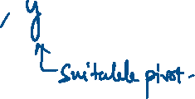



, 

This implies

, 



, 



98% confidence interval for  is 

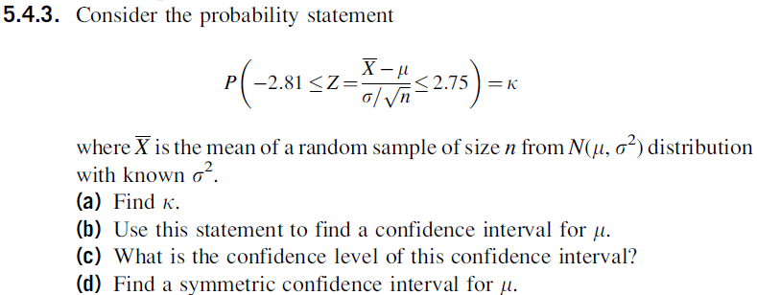

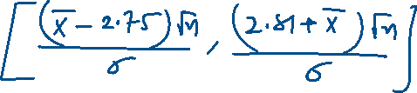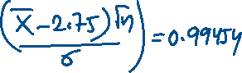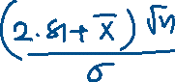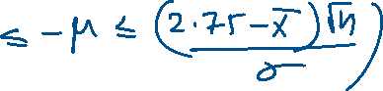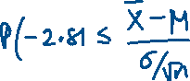

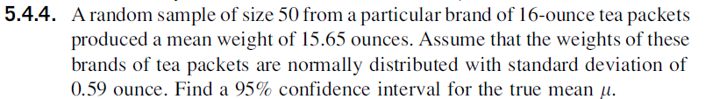

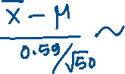

a

